**THE TITLE OF THE PROJECT**

**FINAL REPORT**

**CMSE 322**

**PROJECT NO :01**

**GROUP NO :16**

**PROJECT NAME : Application Fostering Social Connections for Elderly Well-Being**

**PROJECT START DATE :06.03.2024**

**PROJECT END DATE :30.06.2024**

**SUPERVISOR :Nada KOLLAH**

**SEMESTER TERM :2024 Spring Semester**

**Computer Engineering Department**

**Eastern Mediterranean University**

**Term: 2023-2024**

**ABSTRACT**

This project aims to provide a solution for the severe problem of loneliness and social isolation faced by the elderly in Northern Cyprus. This project, through the application of technology, will improve the social connectedness of senior citizens to enhance their lives with a straightforward, user-friendly, and convenient digital platform. This application will assist the elderly to communicate, interact, and engage in social activities using mobile applications and web-based systems. Most importantly, it is through all these features that the project gains enormous relevance in the post pandemic era of Covid-19, which evoked a perceptible increase in the experience of loneliness in the older populations across the globe. This project was developed using agile methodologies and includes some characteristics related to health services, exercise and health advice, chat rooms, and games. Most importantly, the characteristics of this application primarily enchantment the innovativeness of the application because it is used while in collaboration with healthcare professionals to provide support in an attempt to lower healthcare costs as well as improving the well-being of the elderly. Once the project reaches the final steps the platform will be tested with all kinds of users, and their feedback will be used to enhance more secure, and easy to use for many users. The results of this project will bring massive social, economic, and environmentally helping people to be sustainable while at the same time reducing the burden on the health systems.

**Keywords**: the elderly, well-being, social isolation, digital platform, healthcare collaboration, impacts of COVID-19, social interaction.

Table of Contents

- ABSTRACT.............................................................................................................. III

- Table of Contents .......................................................................................................VI

- LIST OF FIGURES ...................................................................................................V

- LIST OF TABLES ....................................................................................................VI

1. INTRODUCTION .................................................................................................... 1

2. PROJECT PLANNING AND MANAGEMENT .................................................... 2

3. REQUIREMENTS ANALYSIS .............................................................................14

- 3.1 Functional Requirements .................................................................................14

- 3.2 Non-Functional Requirements ........................................................................18

- 3.3 Realistic Constraints ........................................................................................19

- 3.4 Ethical Issues ...................................................................................................20

4. DESIGN ..................................................................................................................21

- 4.1 High Level Design (Architectural) ....................................................................21

- 4.2 Software Design ................................................................................................24

5. IMPLEMENTATION ..............................................................................................29

- 5.1 Tools, Technologies, and Platforms Used ........................................................29

- 5.2 Algorithms ........................................................................................................29

- 5.3 Standards ...........................................................................................................31

6. TESTING .................................................................................................................32

7. USER GUIDE OF THE SYSTEM ..........................................................................34

8. DISCUSSION ..........................................................................................................41

9. CONCLUSION ........................................................................................................41

10. REFERENCES ......................................................................................................42

11. APPENDICES .......................................................................................................43

# LIST OF FIGURES

Figure 1: Organization Scheme ......................................................................................6

Figure 2: Gantt Chart .....................................................................................................7

Figure 3: Network diagram...........................................................................................11

Figure 4: Use-case diagram..........................................................................................14

Figure 5: Entity-class diagram......................................................................................15

Figure 6: Sequence diagrams........................................................................................16

Figure 7: Activity diagram............................................................................................17

Figure 8: BPMN diagram .............................................................................................17

Figure 9: architecture diagram......................................................................................23

Figure 10:Context Diagrams.........................................................................................24

Figure 11:Database structure.......................................................................................25

Figure 12:Data level 0..................................................................................................25

Figure 13: Data level 1.1 ..............................................................................................26

Figure 14: data level 1.2................................................................................................27

Figure15:ER diagram...................................................................................................28

# 

# LIST OF TABLES

Table 1: Project Summary ..............................................................................................2

Table 2: Project Team ....................................................................................................5

Table 3: List of Risks ......................................................................................................8

Table 4: Instrument / Equipment / Software / Release Purchases .....………………….9

Table 5: Quarterly Estimated Cost Form ......................................................................12

# 1. INTRODUCTION

Feeling of loneliness and social isolation has been an issue affecting people for some time now. With the COVID-19 outbreak this problem has been on the rise and affecting a lot of people. Most significantly, the elderly population around the globe have been experiencing loneliness on an utmost level. According to a report by the AARP Foundation, loneliness among older adults can lead to numerous negative health outcomes, including depression, anxiety, cognitive decline, and even premature mortality. Also, the World Health Organization (WHO) has reported a worldwide increase in mental health problems in the last 10 years. Reflecting on this it indicates that in the upcoming years more and more people suffer from loneliness and social isolation therefore creating a huge social problem as well as become a burden on health care providers. To tackle this problem previously, several technology companies have attempted to aid this issue through utilization of several methods and developments. Some examples include companion robots like Paro a robotic therapy pet and Jibo which is a robot that forms interaction with humans, voice activated assistants i.e. Amazon Alexa and Google Assistant and lastly the most well-known ElliQ, a proactive social robot specifically designed for elderly. However, all these technologies are not without their limitations and something more renovative and accessible is needed. Considering this need, we aimed to develop an accessible digital platform which will help and assist elderly people in Northern Cyprus in terms of loneliness and social isolation, helping elderly people to live happier, healthier, increase their quality of life and core connected lives.

.

# 2. PROJECT PLANNING AND MANAGEMENT

**Summary of Project**

It was developed to reduce the social isolation of the elderly and increase their well-being. This project enables senior citizens to communicate with each other, interact and participate in social activities through mobile applications or web-based platforms. Thus, elderly people feel in a more active society and increase their social interactions. This project provides an effective solution to improve the well-being of older people and improve their quality of life.

**Key Words**

Elderly People

Welfare

Social Links

Mobile Technology

Community

Social Interaction

Social Support

Life Quality

**Aim of Project**

The aim of the project is to strengthen the social connections of older individuals through mobile applications or web-based platforms to reduce their social isolation and improve their well-being.

**Innovative Aspects/Contributions of Project**

The innovative aspects of the project are that it provides personalized support to seniors by strengthening their social connections through technology and improves their well-being by collaborating with healthcare professionals.

**Methods to be Applied**

**Market Research and Analysis:** Conducting detailed market research to understand the needs and preferences of the elderly.

**Technological Development:** Development of user-friendly mobile applications or web-based platforms for seniors.

**User Feedback:** Receiving feedback from elderly users during the project process and continuously improving the applications.

**Expert Collaboration:** Involving experts such as health professionals, psychologists and social workers in the project process.

**Community Engagement:** Implementing features such as events, chat rooms, and group activities to increase social interactions of older individuals.

**Reason of starting this project**

The main aim of this project is to strengthen the social connections of older people and improve their well-being by using technology. An innovative approach has been adopted to meet basic needs such as access to technology, social interaction and participation in society. In this way, it is aimed for elderly individuals to live a healthier, happier and independent life.

**Economic and National Outcomes**

The economic effects of the project occur through a reduction in health expenditures and an increase in the general welfare of the society.

**Reason of Starting the Project, Methods and R&D Stages**

**Purpose of this project.**

This project aims to provide innovative solutions through mobile applications or web-based platforms to strengthen the social connections of older individuals and improve their well-being.

* Output of project
* National / international standards if exist
* The specific objectives of the project
* Success criteria
* Realistic constraints

The outcome of the project will be a mobile application or web-based platform that will be used to strengthen the social connections of seniors. This project has the goal of meeting certain national or international standards. While the specific goals of the project include increasing the elderly's access to technology, reducing their social isolation and ensuring their greater integration into society, the success criteria are that users use the application frequently, increase social interactions and observe improvements in the welfare of the elderly. Realistic constraints may include financial limitations, technological deficiencies, and differences in the adaptation processes of older users to technology.

**Project Management and Organization**

# Table 2: Project Team

|  |  |  |  |  |  |  |
| --- | --- | --- | --- | --- | --- | --- |
| **Personnel Name** | **Title** | **ID** | **Education Status** | **Graduation Date** | **Date of Starting Work** | **Idea Owner** |
| Hasan Oduncuoglu | User Interface Designer/Tester | 17330170 | Undergraduate | 2025 | 07/03/2024 | Yes |
| Aleyna Yılmaz | Project Manager/Data Base Team Leader/Data Base Developer | 21000166 | Undergraduate | 2025 | 07/03/2024 | Yes |
| Doğukan Güler | Programmer/ Analyst | 17000252 | Undergraduate | 2025 | 07/03/2024 | Yes |

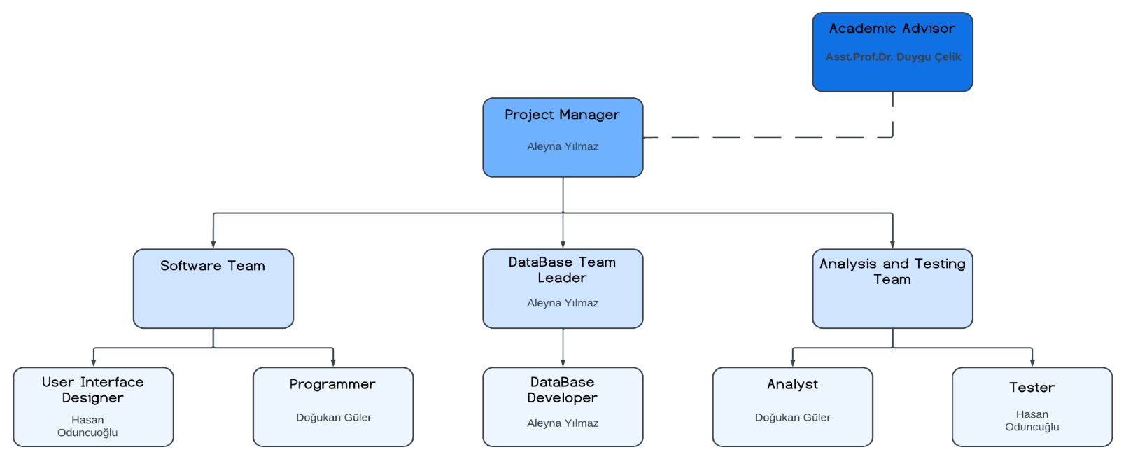Figure 1:Organization Scheme

# metin, ekran görüntüsü, sayı, numara, yazılım içeren bir resim Açıklama otomatik olarak oluşturuldu Figure2:

# Gantt Chart

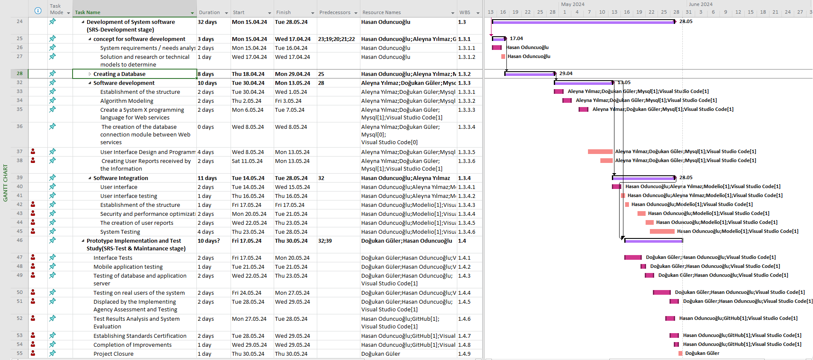

# Table 3:List of Risks

|  |  |  |  |
| --- | --- | --- | --- |
| Risk | Probability | Effects | Your Strategy |
| The time required to develop the software is underestimated. | High | Serious | It is necessary to implement strategies such as detailed planning, regular communication, risk management and flexibility. |
| Software tools cannot work together in an integrated way. | High | Tolerable | To ensure integration between software tools, a strategy should be followed using standard data formats and integrating with compatible APIs. |
| Customers fail to understand the impact of requirements changes. | Moderate | Tolerable | It is important to communicate regularly and clearly explain the impact of changes on project objectives. |
| The rate of defect repair is underestimated. | Moderate | Tolerable | Replace potentially defective components with more reliable bought-in components. |
| The size of the software is underestimated. | High | Serious | Investigate buying sw components;  Investigate use of a program generator. |
| Code generated by code generation tools is inefficient. | Moderate | Insignificant |  |
| Key staff are ill at critical times in the project. | Moderate | Serious | Reorganize team so that there is more overlap of work and people therefore understand each other’s jobs. |
| The database used in the system cannot process as many transactions per second as expected. | Moderate | Serious | Investigate the possibility of buying a higher-performance database. |

**Table 4:Instrument / Equipment / Software / RELEASE PURCHASES**

|  |  |  |  |  |  |  |  |  |  |  |  |
| --- | --- | --- | --- | --- | --- | --- | --- | --- | --- | --- | --- |
| **Project Name** | |  | | | | | | | | | |
| **Line no** | **Instrument / Equipment / Software / Publication Name** | | **No. of Item** | **Capacity** | **Technical specification** | **Purpose of Project Activities** | **Post-Project Place of Use / Purpose** | | **Unit Price (USD)** | **Unit Price (TL)** | **Total Amount (TL)** |
| **R & D** | **Production** |
| **1** | **Laptop** | | **4** | **-** | **512gb minimum with 100gb unused space and Core i5/i7 quad-core 2.2GHz or faster** | **Involved in every task of the project** | **Yes** | **Yes** | **1,200** | **40,000** | **160,000** |
| **2** | **Internet Connection** | | **1** | **-** | **Min. 20Mbps** | **Connection** | **Yes** | **Yes** | **275** | **8,900** | **8,900** |
| **3** | **MS Project** | | **1** | **-** | **Project Management Software** | **Planning** | **Yes** |  | **30** | **1,000** | **1,000** |
| **4** | **Office 365** | | **1** | **-** | **Collection of office-related applications** | **Management** | **Yes** |  | **100** | **3,300** | **3,300** |
| **5** | **Modelio** | | **1** | **-** | **Tools for drawing diagrams** | **UML Diagrams** | **Yes** |  | **-** | **-** | **-** |
| **6** | **MySQL** | | **1** | **-** | **Tools for creating database** | **Database Operations** |  | **Yes** | **4,280** | **140,000** | **140,000** |
|  |  | |  |  |  |  |  |  |  | **TOTAL** | **313,200 TL** |

Figure 3:Network diagram

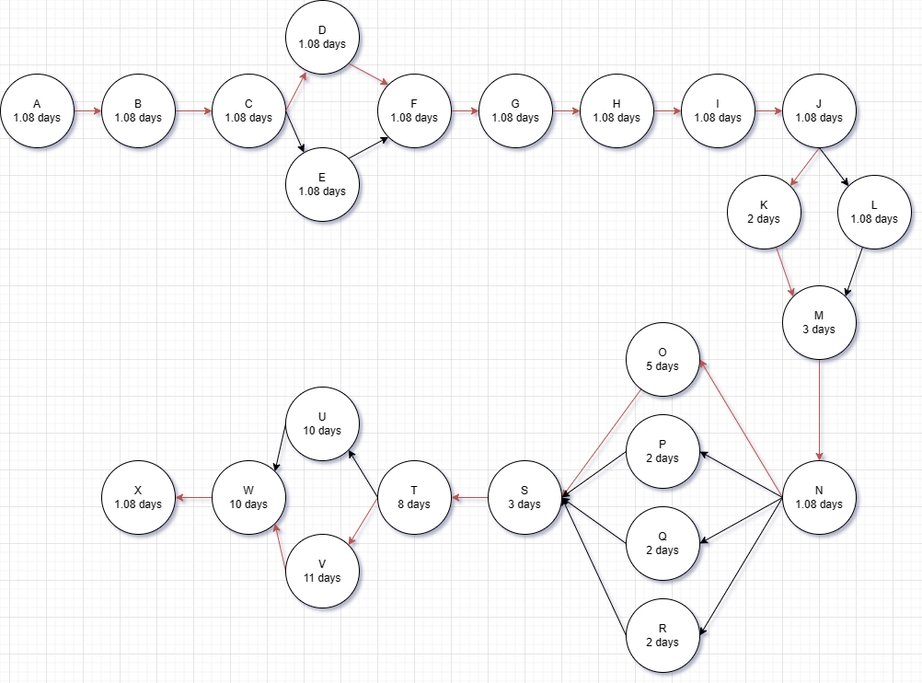

**Table 5:Quarterly Estimated Cost Form (TL)**

|  |  |  |  |  |
| --- | --- | --- | --- | --- |
| **Project Name :** | | | | |
| **Cost Item** | **2024** | | **TOTAL**  **(TL)** | **TOTAL COST RATE OF CONTENTS (%)** |
| **I** | **II** |
| **Personnel** | 30,000 | 30,000 | 60,000 | 26 |
| **Travel** | 10,000 | 10,000 | 20,000 | 9 |
| **Instrument / Equipment / Software / Publications** | 10,000 | 10,000 | 20,000 | 9 |
| **Domestic Works Made By R & D and Testing Institutions** | 25,000 | 25,000 | 50,000 | 21 |
| **International Works Made By R & D and Testing Institutions** | - | - | - | - |
| **Domestic Services Procurement** | 12,000 | 12,000 | 24,000 | 11 |
| **Overseas Service Procurement** | - | - | - |  |
| **Material** | 30,000 | 30,000 | 60,000 | 24 |
| **TOTAL COST** | 117,000 | 117,000 | 234,000 | 100 |
| **CUMULATIVE COST** |  |  |  | 100 |
| **IN THE PROJECT TOTAL MAN-MONTH** | | | 234,000 | |

# 

# 3. REQUIREMENTS ANALYSIS

## 3.1 Functional Requirements

New users shall be able to register.

Returning users shall be able to login.

Logged in users shall be able to logout.

Elderly people shall be able to change their password.

Elderly people shall be able to edit/manage their profile.

Elderly people shall be able to adjust the language settings of their account.

The system shall notify users in case of invalid data fields.

User and Actors are doctors, nurses, users and admin.

Figure 4: Use-case diagram

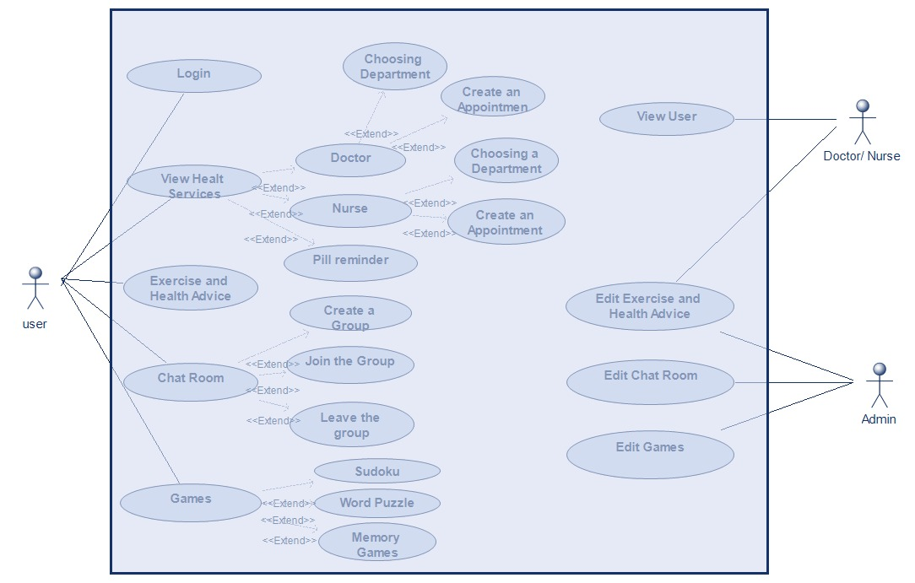

Figure 5:Entity-class diagram

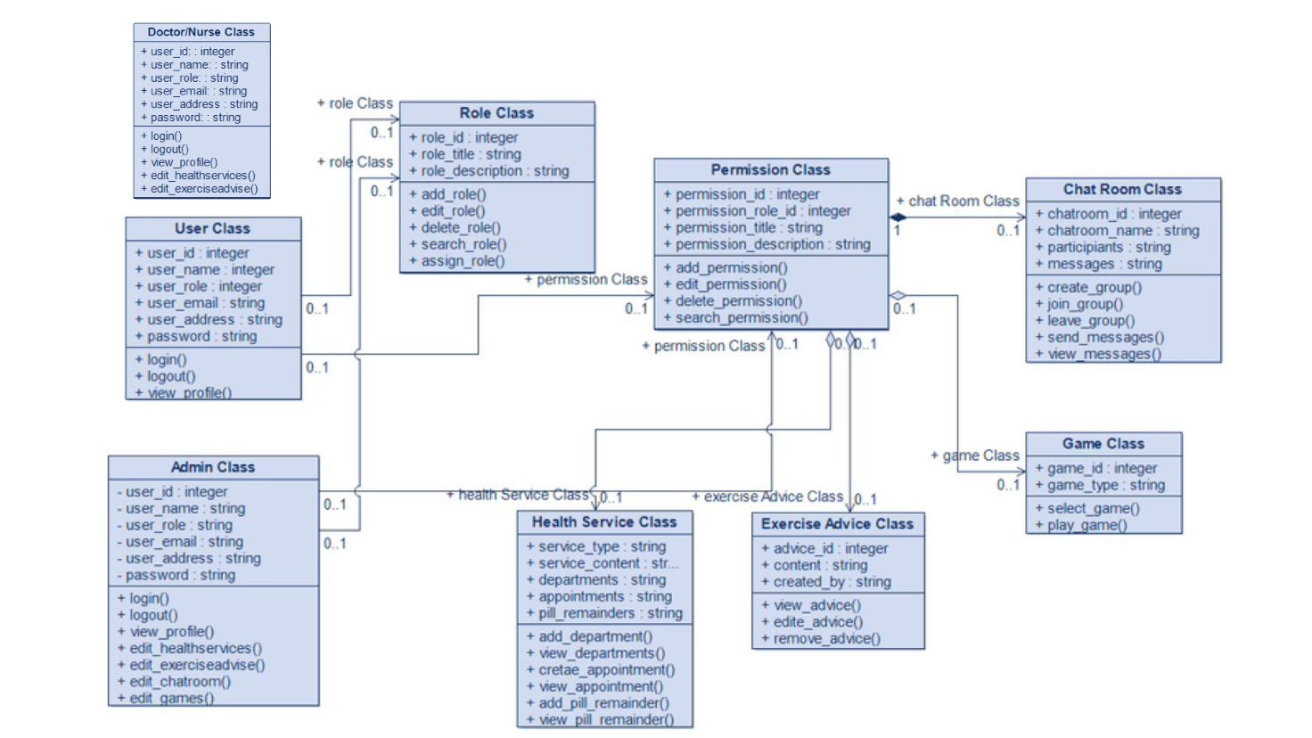

Figure 6:Sequence diagrams

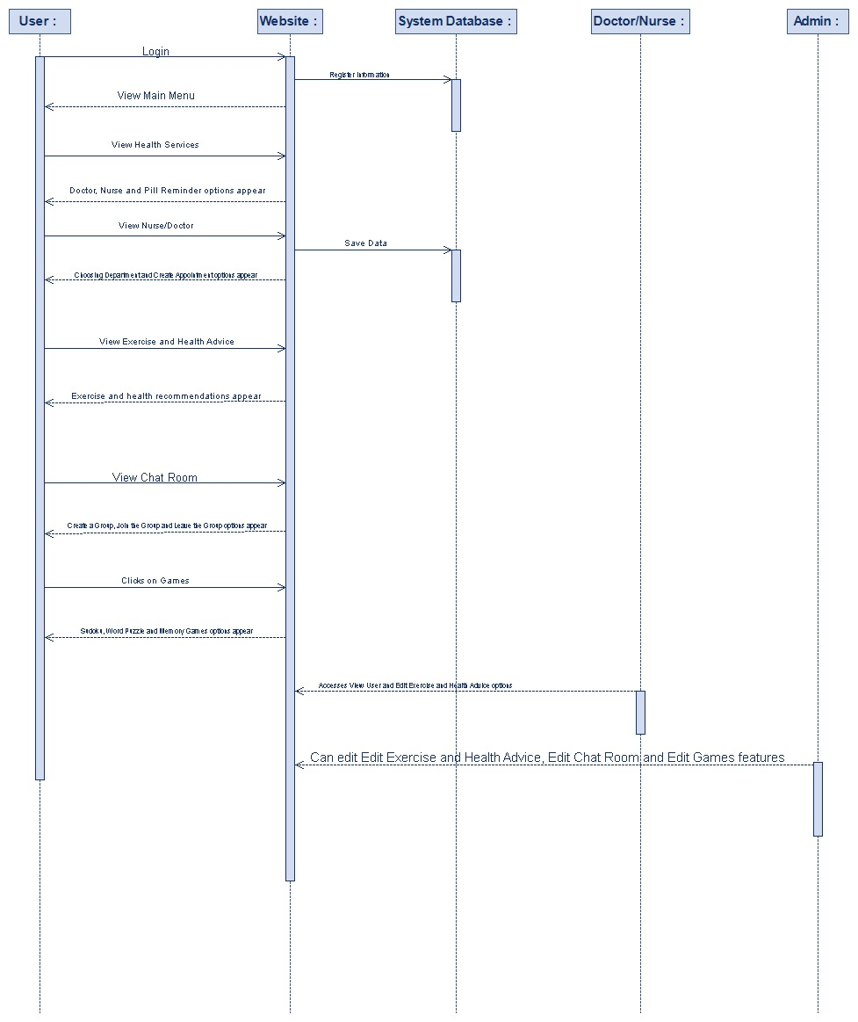

Figure 7:Activity diagram



Figure 8:BPMN diagram

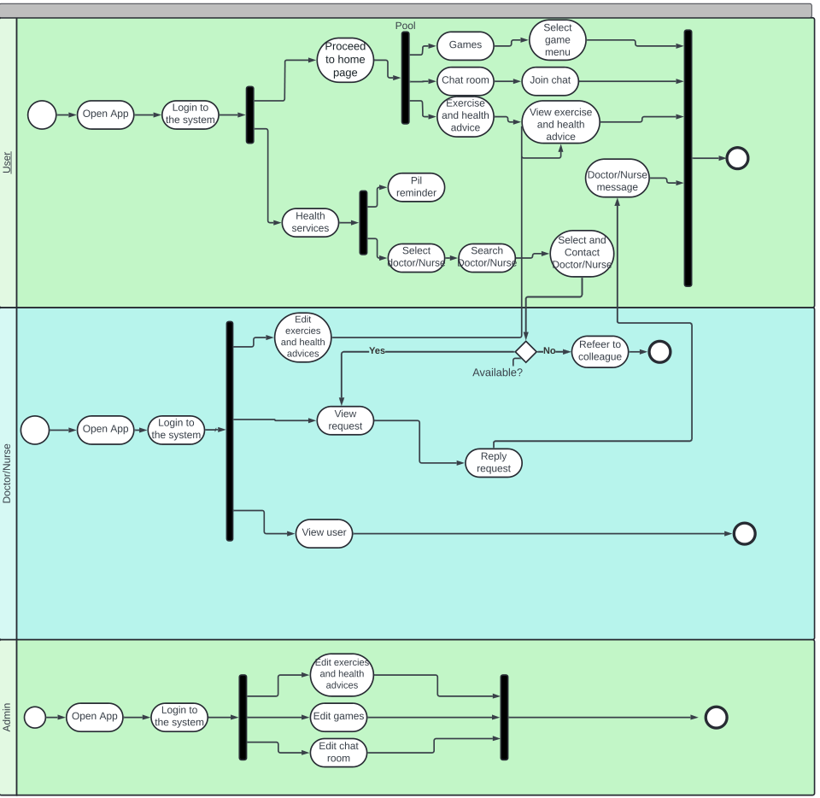

## 

## 3.2 Non-Functional Requirements

# Nonfunctional Requirements

## Performance Requirements

Applications should be responsive, which is by performing low latency to the user interaction.

Ensure time for page loading and action execution of function to boost user experience.

## Safety Requirements

Encrypt all the user data and conversations in order to avoid unapproved access by third parties.

Employing stricter authentication and permission procedures for identity authentication and limiting the access to sensitive features will be one measure.

Security audits and upgrades are to be implemented as a regular process in order to deal with the potential weaknesses.

## Security Requirements

Encrypt all the user data and conversations in order to avoid unapproved access by third parties.

Employing stricter authentication and permission procedures for identity authentication and limiting the access to sensitive features will be one measure.

Security audits and upgrades are to be implemented as a regular process in order to deal with the potential weaknesses.

## Software Quality Attributes

**Usability:**

•The system should include a questions page for user’s to ask questions or complaints about the application

•The system should have a frequently answered questions page to tackle major frequent issues that user’s might have with using the application.

•The system should have a well formed, easy to use graphical user interface

•The system should be user friendly

•The system must be easy to learn for both novices and users with experience from similar systems

•The system must be efficient for the frequent user

•The system must be easy to remember for the casual user

•The user must understand what the system does

•The user must feel satisfied with the system

**Supportability:**

•The system should be easy to maintain.

• In order for the system to be easy to maintain it is done with an objected oriented language, which is easy to maintain.

•Maintenance of the system should be cost efficient

•Maintenance of the system should be less frequent

•The system should easily adapt to changes made

•The system should be able to detect the location of the user

## Business Rules

Not applicable

## 3.3 Realistic constraints

**Economic:** System will be free of charge for everyone to use therefore, users will not need to invest any form of payments towards the usage or subscription.

**Environmental:** Environmental factors have been investigated from both perspectives; user site and admin panel. From the admin panel site, system is designed to consume as little as possible energy and power since the servers currently been used to develop the system are brand new technology and specifically developed to reduce the power and correlating economic factors occurring in the process. Which also minimizes the energy/power level thus reducing the carbon footprint. On the user site, system will run on user’s devices and will only consume the power provided by the device. Power and energy will depend on the usage but performed experiments indicated that the app is not consuming anymore than other apps on the device (i.e. Games).

**Social:** Are there social constraints? E.g. are certain segments of society prohibited in its use (persons less than 18 years old cannot use etc.)?

**Social**: There are no social constraints.

**Political:** No foreseen political constraints. However, in terms of legal rights and ownership, a full patent request will be submitted to the regulatory bodies once the project reaches final steps to protect the right and ownership of the project to the fullest extend possible.

**Ethical:** This project is one of a kind and unique. No additional “borrowing” of ideas or codes were obtained or used.

**Health and Safety**: System runs in collaboration with health care workers from various areas within the branch of health service delivery. Therefore, any aspect that possesses a possible danger have been identified and resolved.

**Manufacturability:** Necessary raw materials and components are readily accessible, ensuring a reliable supply chain. The manufacturing process optimizes resource use and maintains cost-effectiveness and minimizing waste.

**Sustainability:** Product is designed and developed to sustain for a very long time. However, the need and demand here play a big factor and risk. Since there is a growing elderly population with the need of socializing as well as direct communication with their healthcare providers product will sustain for a very long time.

## 3.4 Ethical issues

While the product was built with good intentions, there is a risk of misuse, which could lead to unethical behavior or illegal activity. Individuals, for example, could use the product maliciously or participate in unethical behavior. However, to mitigate these dangers, we have built extensive security features into the app. These systems are intended to provide strong protection for all parties involved, ensuring a high level of security while preventing unauthorized or unethical use. We hope to prevent any misuse and maintain ethical standards by constantly reviewing and improving our security measures.

# 4. DESIGN

## 4.1 High level design (architectural)

**Assumptions and Dependencies**

**Assumptions**

* The machine could be to be had 24/7.
* Administrator is already created inside the machine.
* Roles and responsibilities are predefined.
* The gadget shall assist all users on the equal time.
* Details concerning elderly profiles shall be entered manually.
* System shall deliver warnings whilst incorrect procedures take region.
* The machine will be secured to defend private user records.
* Related Software or Hardware

The challenge could be designed the use of numerous layout tools like (Modelio, lucid chart, Figma) Implementation of the layout may be carried out the use of HTML, CSS, and Java. MySQL might be used to shop facts inside the database.

**End - User Characteristics**

**Administrator:** The administrator is the user that manages Modules Information, manage transactions, approve paperwork, create elderly profiles, schedule chats, and plenty of greater…

**User:** might be able to use all device capabilities, provoke chats, have interaction in group sports, and access assets for nicely-being, additionally be able to play video games, benefit from health services and chat with other elderly human beings.

**General Constraints**

The machine should be capable of run on any working system and any browser.

All customers should have net connectivity before connecting to the system.

The device ought to offer fast response time.

The device need to offer the fine security requirements and techniques to protect registered personal person info.

**Goals and Guidelines**

**Goal:** The number one intention of developing this kind of device is to provide accessibility to aged people international, fostering social connections and properly-being. We aim to reduce social isolation and decorate fine of lifestyles by means of presenting a platform that helps significant interactions and get admission to to assets tailored to their needs. Despite present solutions within the market, we aspire to innovate and offer specific functions that address the unique demanding situations faced by means of elderly people.

**Guidelines**

The KISS (Keep It Simple Stupid) approach might be used when designing the system to make sure ease of use for aged users.

The machine might be designed in a way that feels intuitive and familiar to elderly customers, selling adoption and engagement.

The machine will prioritize fast response time to beautify consumer experience and engagement.

**Development Methods**

The method which will be used within the development of the system is "Agile" that's an iterative and incremental improvement technique. In iterative improvement approach, the product is advanced little by little, that is, the system is damaged into smaller chunks. In incremental development technique, the gadget is designed, applied, and tested incrementally.

Reasons for the use of the iterative and incremental development techniques collectively:

It reduces the chance of delay.

It is less complicated to test and debug at some stage in a smaller new release.

Repetitions of the exclusive phases can be built to ensure that the gadget sincerely meets the expectations of the client.

Defects may be determined on the early levels.

**Architectural Strategies**

**Modifying for Betterment**: We must enhance the current system. We can use past experiences and methods to make the project last and easier to manage.

**Website Basics**: We need a single place for all web tools. This spot should be online. Only admins can change and use it.

**Linking to Data**: We should link the database to the same web network. It should back real-time shifts. Keep up the database on the main computer.

**Outside Data**: We won't use outside databases. All data work will stay with the local one.

**Trust and Working Together:** The net must be strong. It should fix any issues with the web tools. Users need safe ways to see and work with data.

# 

# System Architecture

Figure 9:System architecture diagram

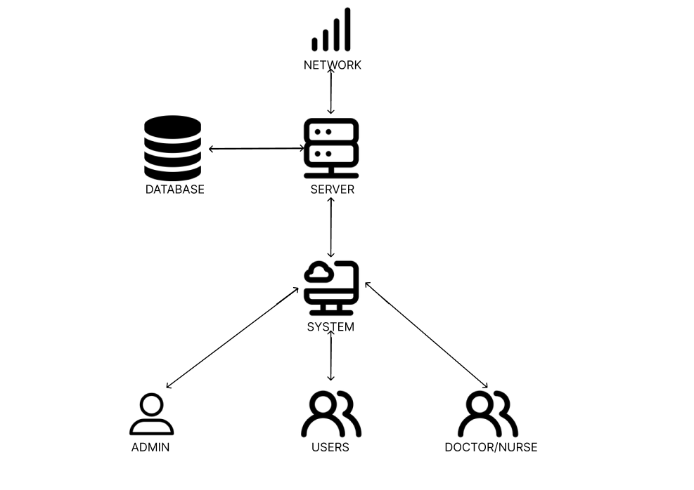

Figure 10:Context Diagrams

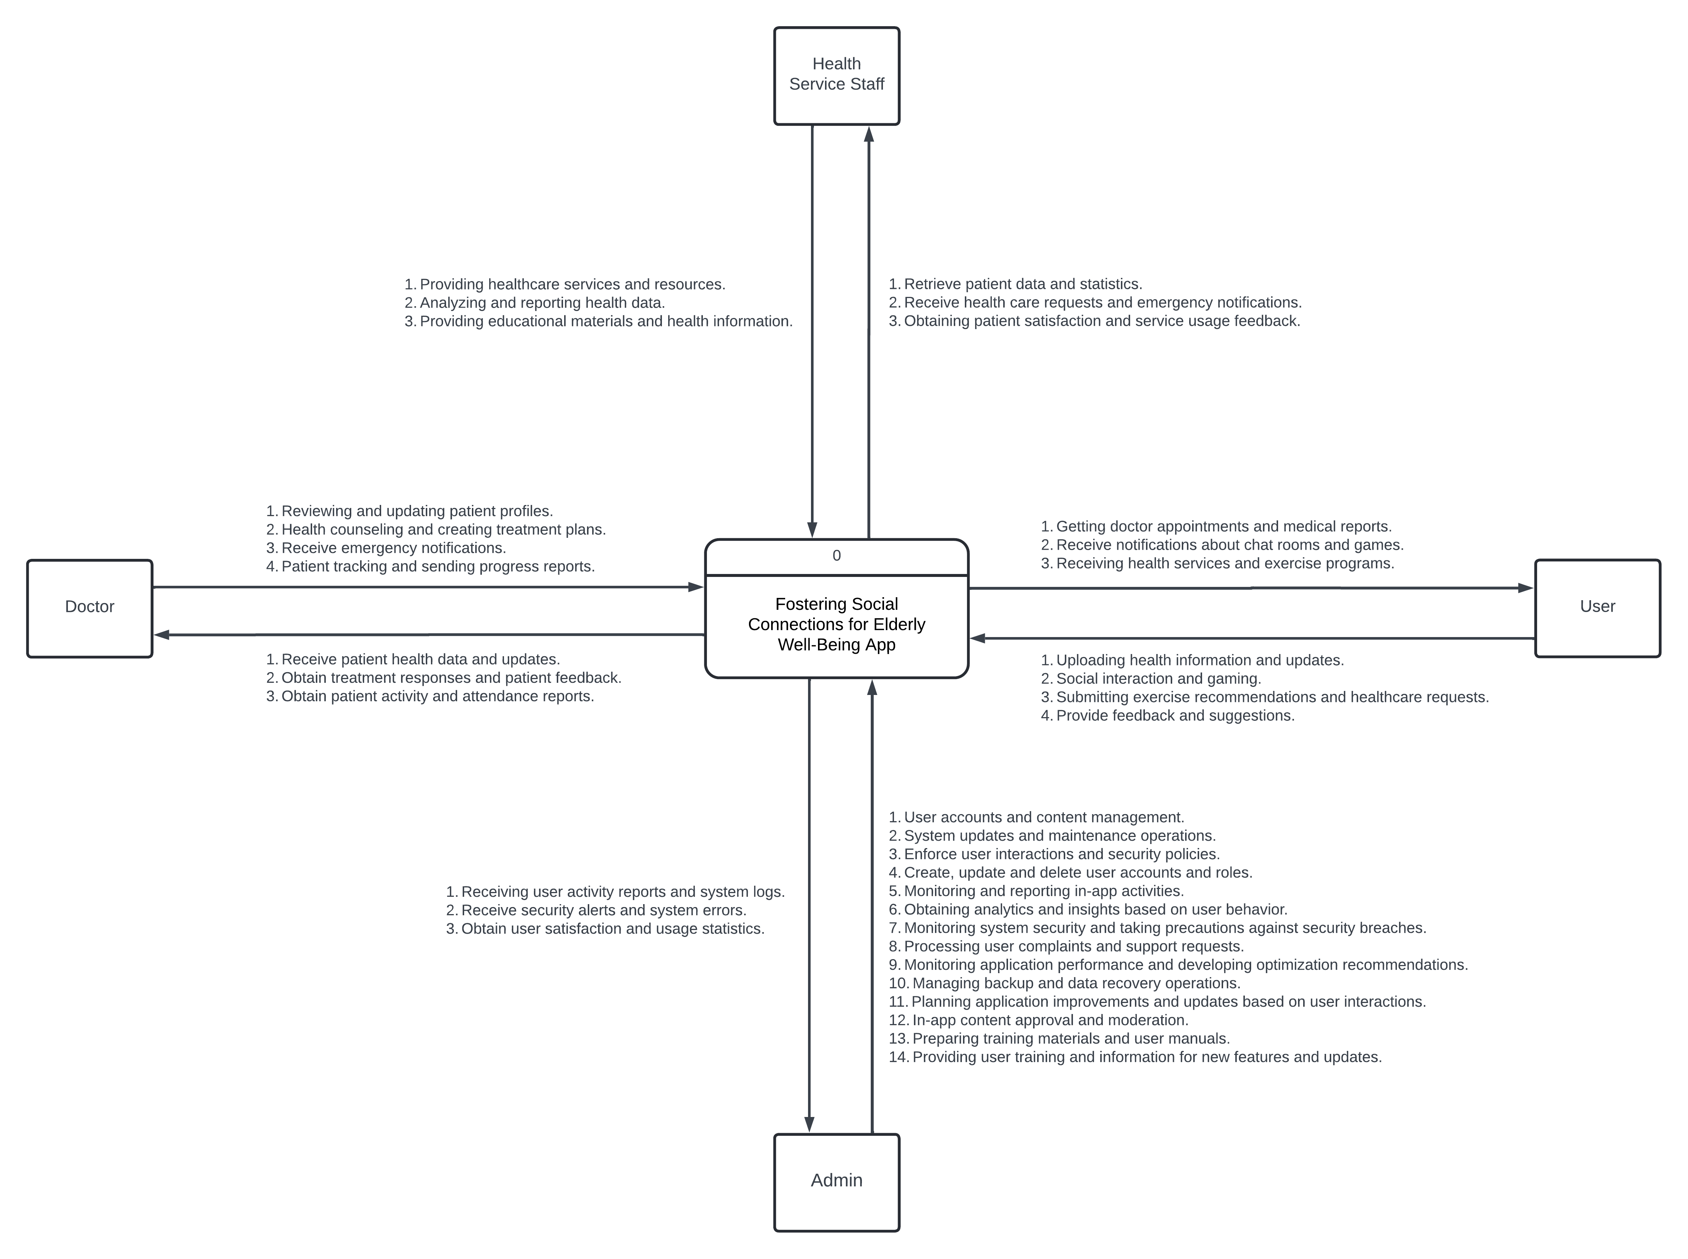

## 

## 2 4.2Software design

The provided diagram illustrates a comprehensive database structure for a health-related application, comprising several interconnected tables. The primary tables include User, Doctor, Health Service, Game, Exercise Advise, and Chat Room, each with distinct fields and relationships. The User table stores user information and links to Health Service via service_id. The Doctor table contains doctor details, linked to users through user_id, and connects to the Health Service table, which details various health services provided by doctors. The Game table lists available games, while the Exercise Advise table contains exercise advice, including content and difficulty levels. The Chat Room table holds information about chat rooms linked to users. Key functions and procedures include user management (creating, updating, deleting users), doctor management (adding, updating, deleting doctors), health service management (creating, updating, deleting services), game management (adding, updating, deleting games), exercise advice management (adding, updating, deleting advice), and chat room management (creating, updating, deleting chat rooms). Additionally, security procedures such as user authentication, data encryption, and access control are implemented to ensure data integrity and protection. These functions and relationships ensure the smooth operation and management of the health application, maintaining both functionality and security.

Figure 11:Database structure:

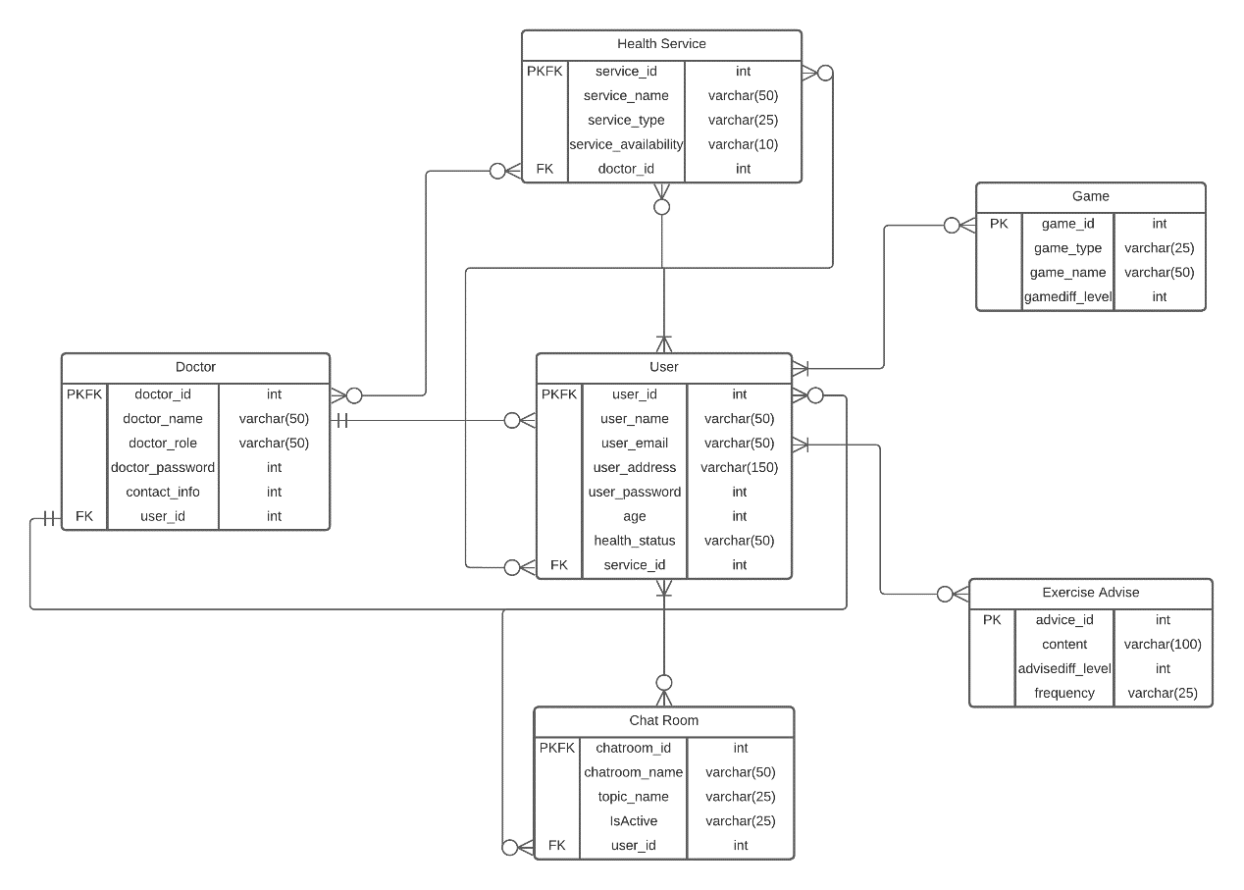

Figure 12:Data level 0

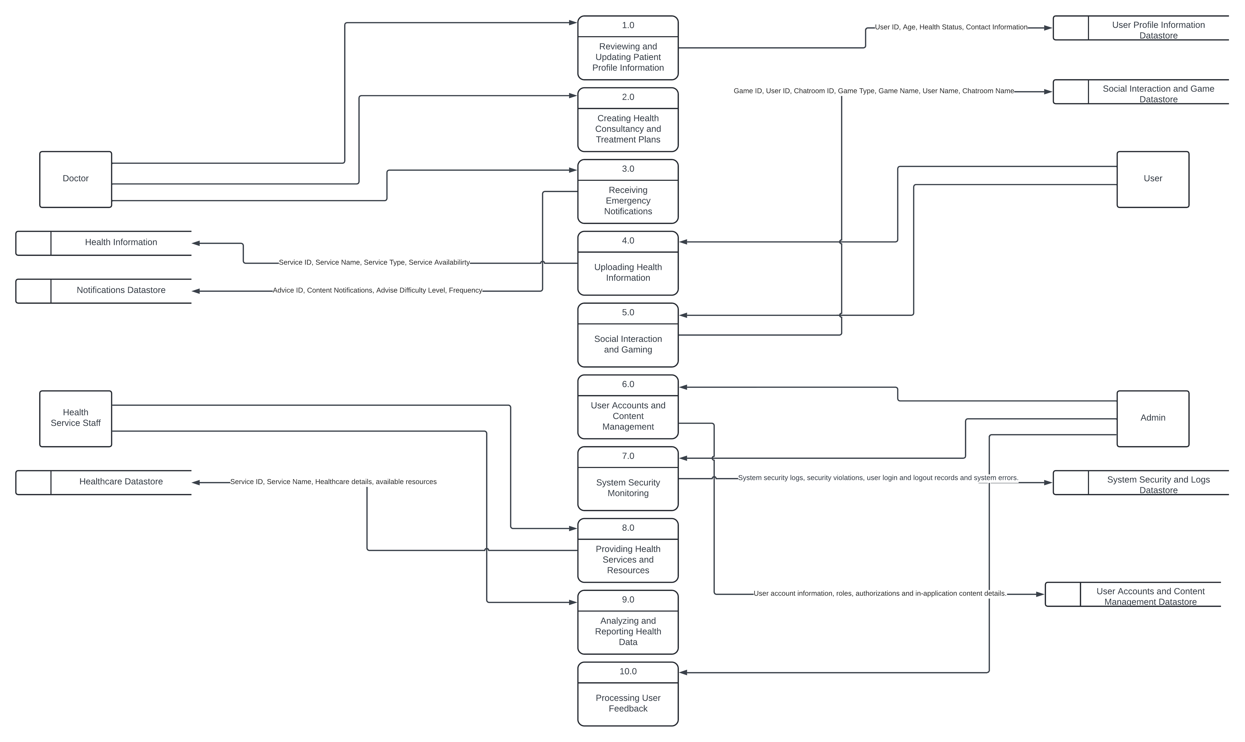

Figure 13:Data level 1.1

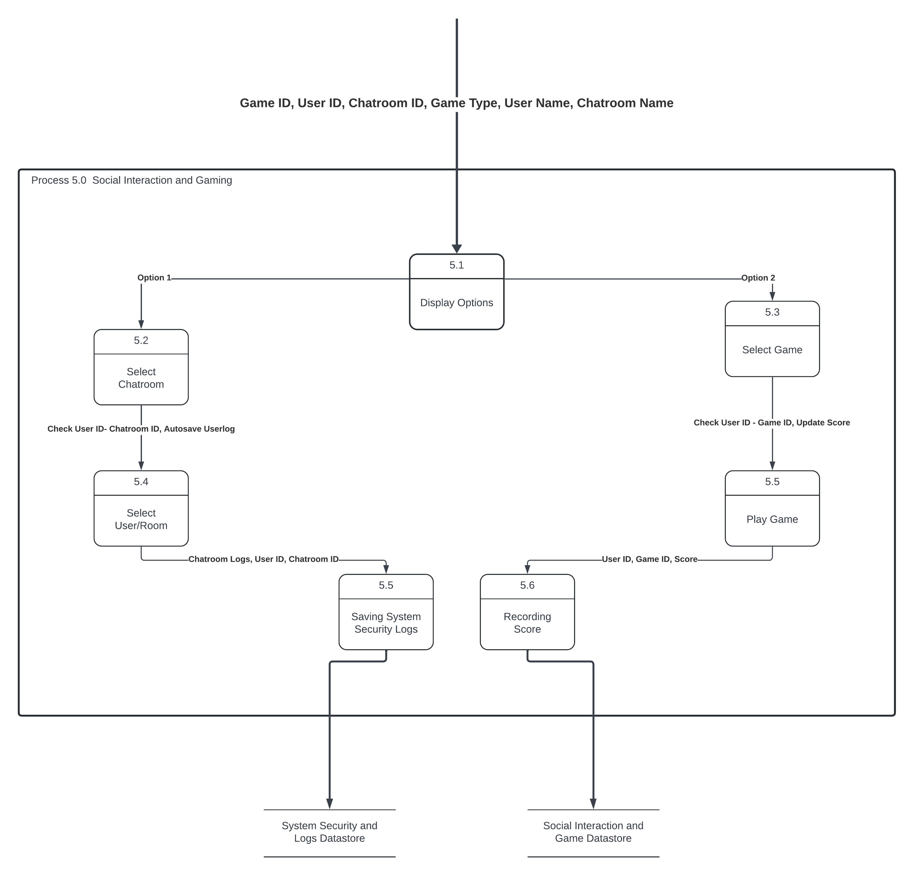

Figure 14:data level 1.2

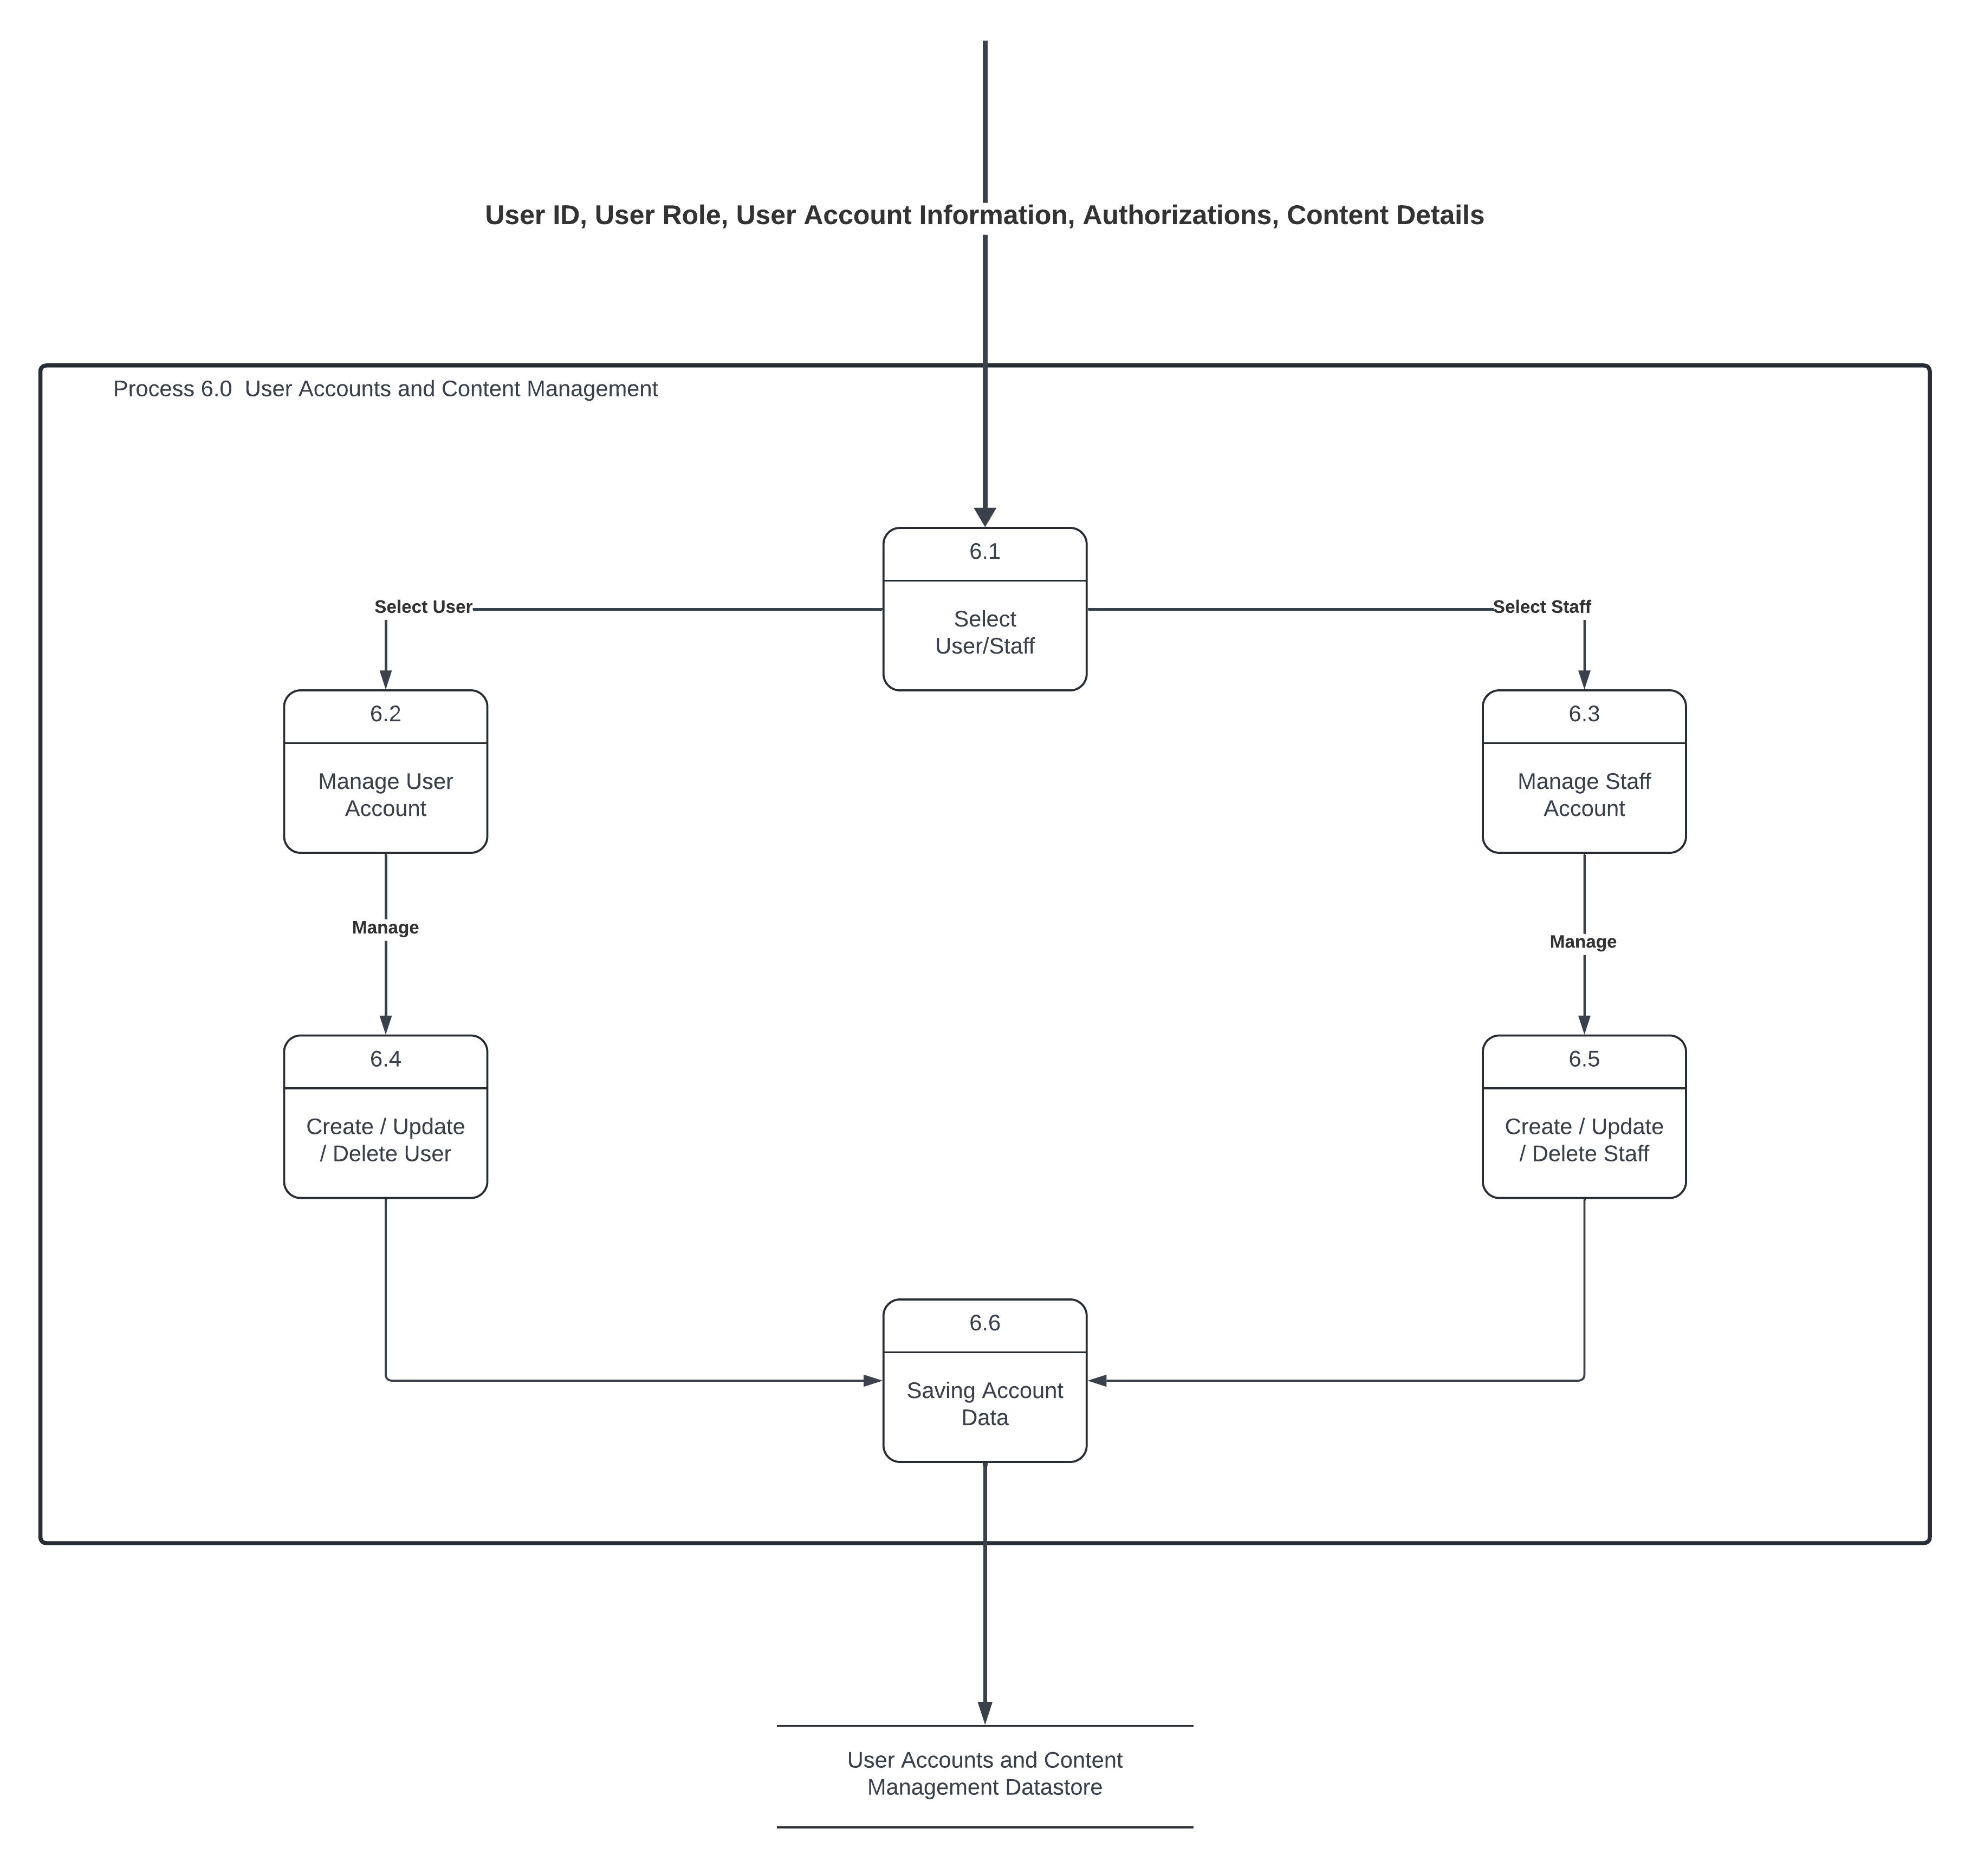

Figure 15:ER diagram

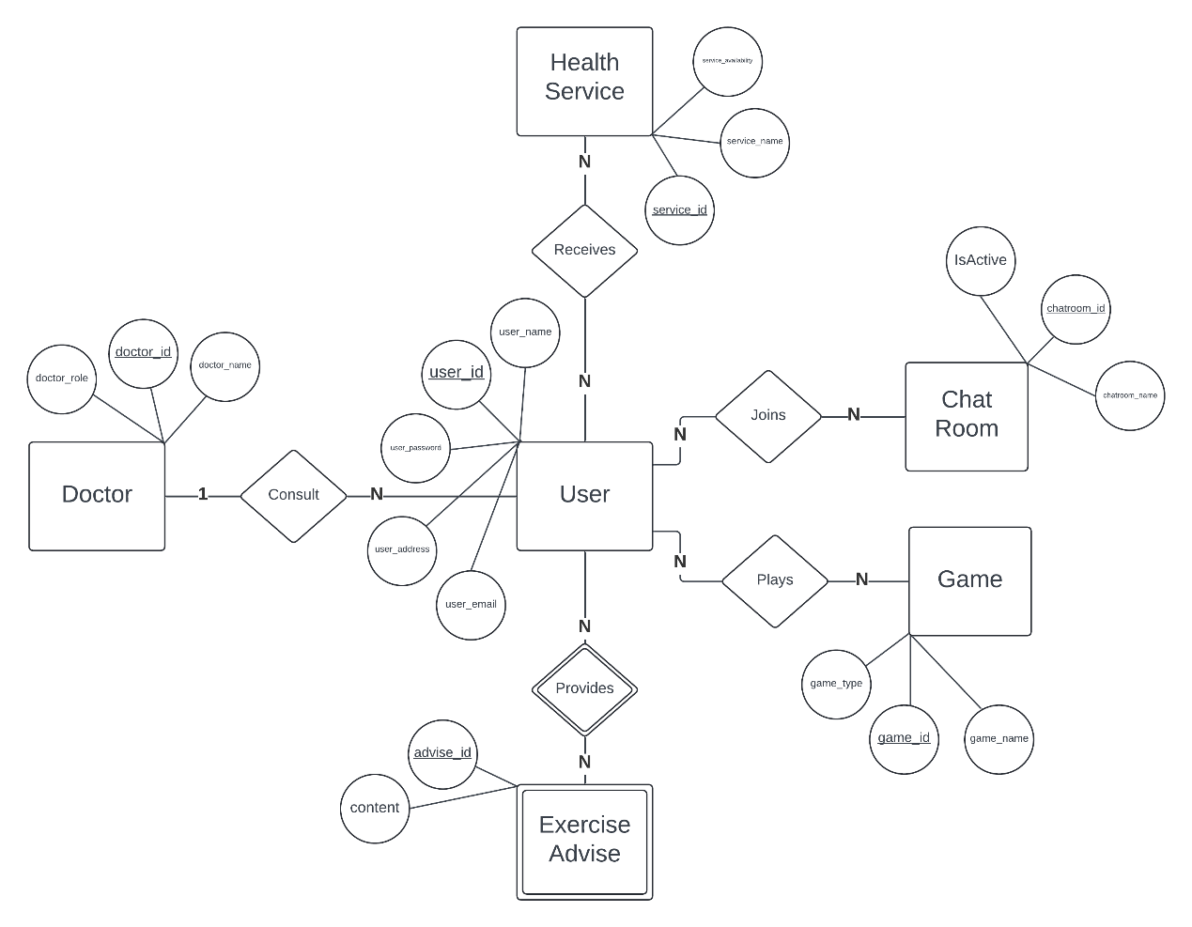

# 5. IMPLEMENTATION

## 5.1 Tools, technologies and platforms used

* Elementary web technologies, HTML, CSS, and JavaScript were used to invent web pages and add interactivity.
* A database is needed to save user information, content management and other data. MySQL database system was used. Hence, adding, updating, and selecting information from the database will be extremely simpler.
* Figma application was used to generate the design and UI design of the website.
* The testing phase of the website was carried out using Jest and Jasmine testing tools.
* The use of avoidable code was prevented to make the system work quicker and more effectively.

## 5.2 Algorithms

Start of the Program:

Start application:

Upload configurations

Connect to the database

Start the necessary services

Install the security configuration:

Define user verification and authorization rules

Manage unauthorized access situations

The main loop:

Listen to requests from the user

Forward to the corresponding controller according to the request type:

If the request is a user transaction:

Redirect to the user controller

The user controller forwards the request to the corresponding user service

The user service processes the request and returns the result

The result is transmitted to the user

If the request is a doctor's procedure:

Refer it to the doctor controller

The doctor controller transmits the request to the relevant doctor's service

The doctor's service processes the request and returns the result

The result is transmitted to the user

If the request is a chat room transaction:

Redirect to the chat room controller

The chat room controller forwards the request to the corresponding chat room service

The chat room service processes the request and returns the result

The result is transmitted to the user

If the request is an exercise recommendation process:

Forward the exercise recommendation to the controller

The exercise recommendation controller forwards the request to the relevant exercise recommendation service

The exercise recommendation service processes the request and returns the result

The result is transmitted to the user

End of The Program:

Stop services

Disconnect the database

End the application

## 5.3 Standards

* **World Wide Web Consortium (W3C):** W3C, an global ideals company, has an powerful accountability in decisive and development web standards. These standards promise that the website displays always among browsers and set customary web development standards.
* **Data Security Standards:** The greatest encryption standards and security procedures would be used to uphold the security of user data. These criteria require database encryption, network encryption, and other security agencies.
* **Accessibility Standards**: Accessibility standards such as WCAG (Web Content Accessibility Guidelines) should be respected to cross the requirements of elderly users. Kinds for instance large font sizes, high-contrast colours and screen reader compatibility make it anxious aimed at elderly users to custom the website.
* **UI/UX Design Standards:** Standards should be pursued in user interface and experience design. Best methods and user experience attitudes should be used to prepare a user-friendly interface.

# 6. TESTING

Test data should be spread to screening numerous scenarios. Real user data should not be used, as an alternative synthetical data or trial data should be used.

Test outcomes frequently uncover numerous flaws or errors. For instance, conflicts in the user interface, flawed functionality, or performance problems. It may be essential to update the software or revision the code to fix these errors.

Lastly, verification and validation processes are used to verify that the final product works perfectly and chances the requirements. This is done by evaluating it with user hopes and requirements.

The possible actions that users would take on the website we designed were tested. Below are images of the testing phase.

**Test1:** In the initial phase of the test, the page acts for the user to positively log in to the system. The user must use the left column to log in to the system. If the user does not have an account, the user can register to the system from the column on the right.

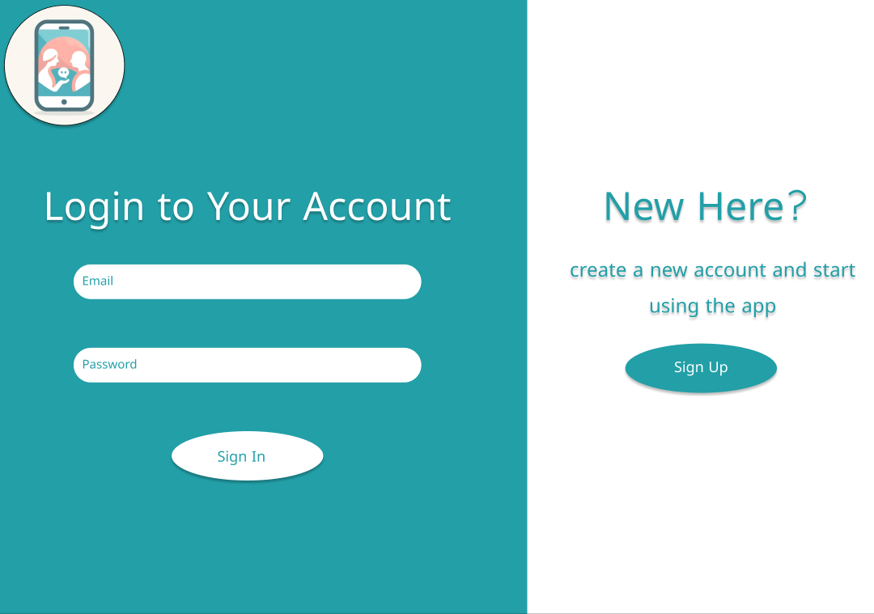

*Figure1.1*: *Login page*

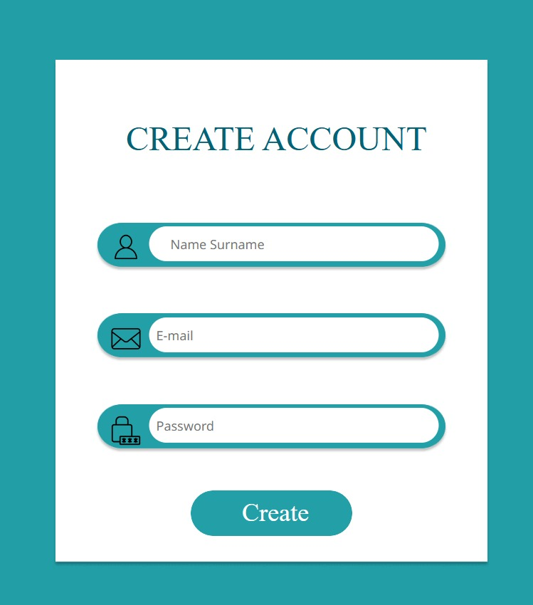

*Figure 1.2: Create account page*

**Test2:** After the user successfully logs in to the system, user is presented with the home page. You can switch to other pages on the website by choosing one of the health services, exercise and health advice, chat room and game options on the home page.

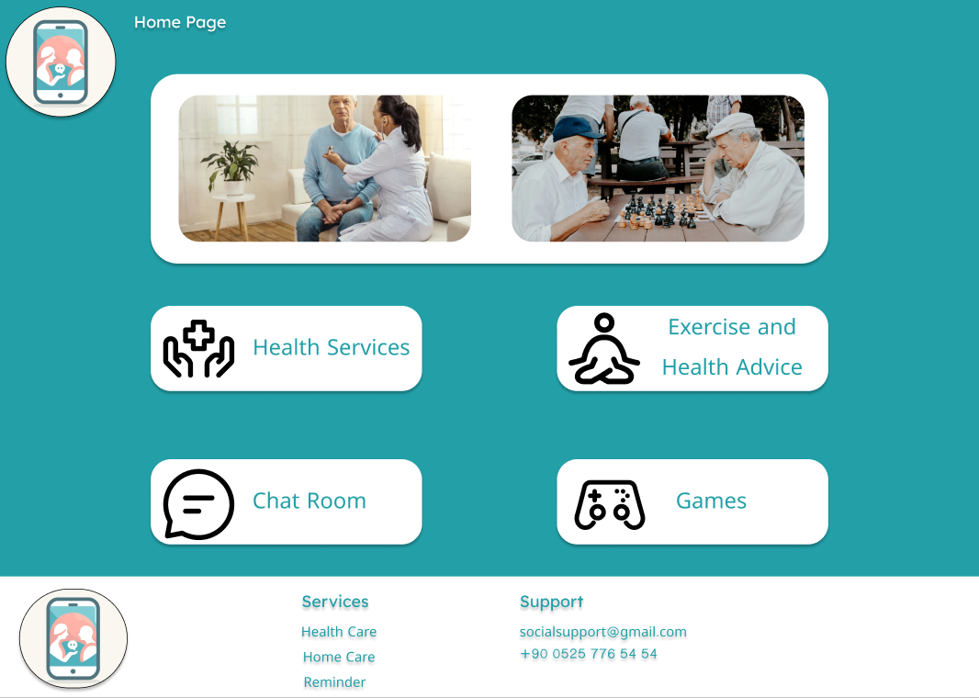

*Figure2.1*: *Home page*

**7. USER GUIDE OF THE SYSTEM**

# There are 4 types of users in the system (Elderly person, Doctor/Nurse, and Manager). The user interfaces for users are the same. Every user is directed to the home page after logging in. All users can use all operations on the home page.

**USER**

When the all user clicks on one of the options on the home page, they are directed to other pages.



*Figure a. : Home page*

After the user clicks on the health services section on the home page, the health services page starts. On this page, doctors and nurses can be selected in line with their segments and an appointment can be made. If the user has pills that he uses repeatedly, he can create an alarm clock by entering the time the pills was used.

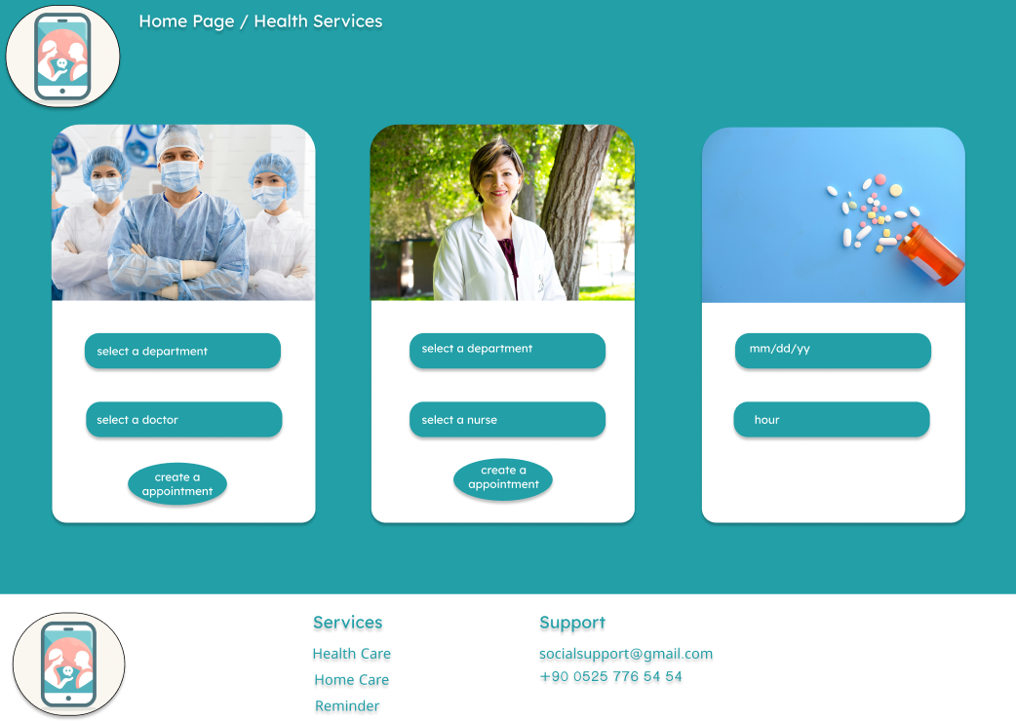

*Figure b. : Health services*

When the user clicks on the exercise and health advice switch on the home page, the exercise and health advice page open. On this page, sections surrounding health and exercise advice for the elderly people are circulated weekly by doctors and nurses.

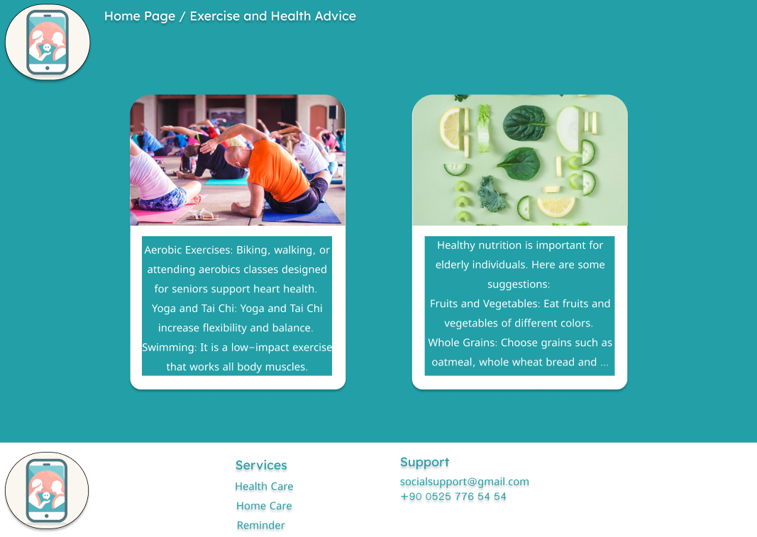

*Figure c. : Exercise and health advice*

When the user clicks on the chat room button on the home page, the user can start a conversation with online users in the chat room.

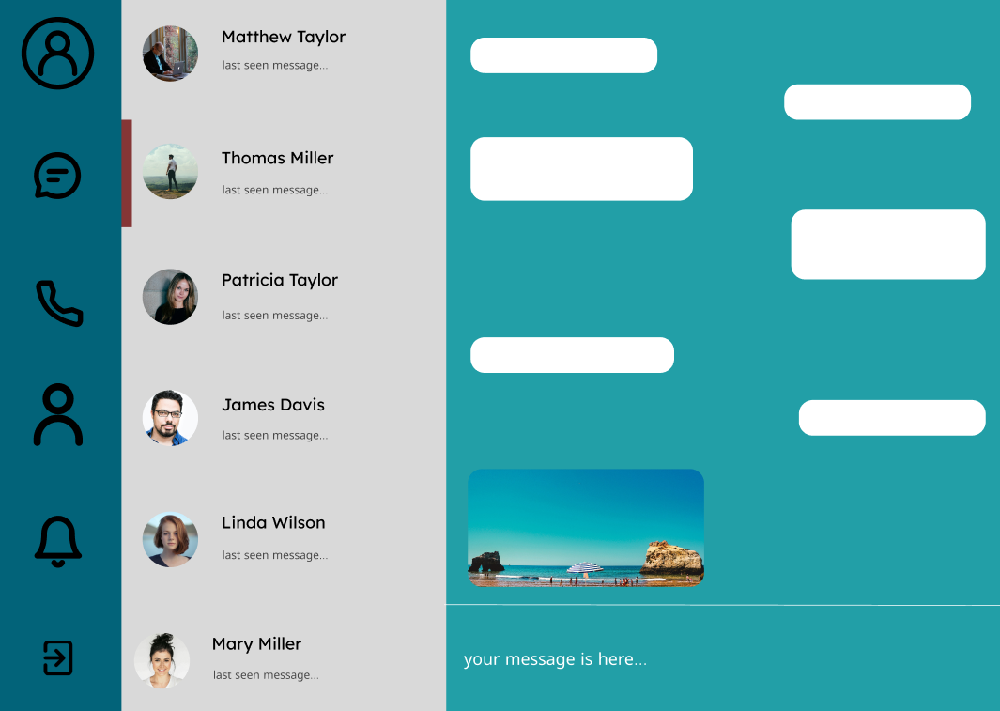

*Figure d. : Chat room*

When the user chooses the games switch on the homepage, user is turned to the page where the games are sited. This page involves sudoku, memory games and word games. The user can select one of these games and start playing.

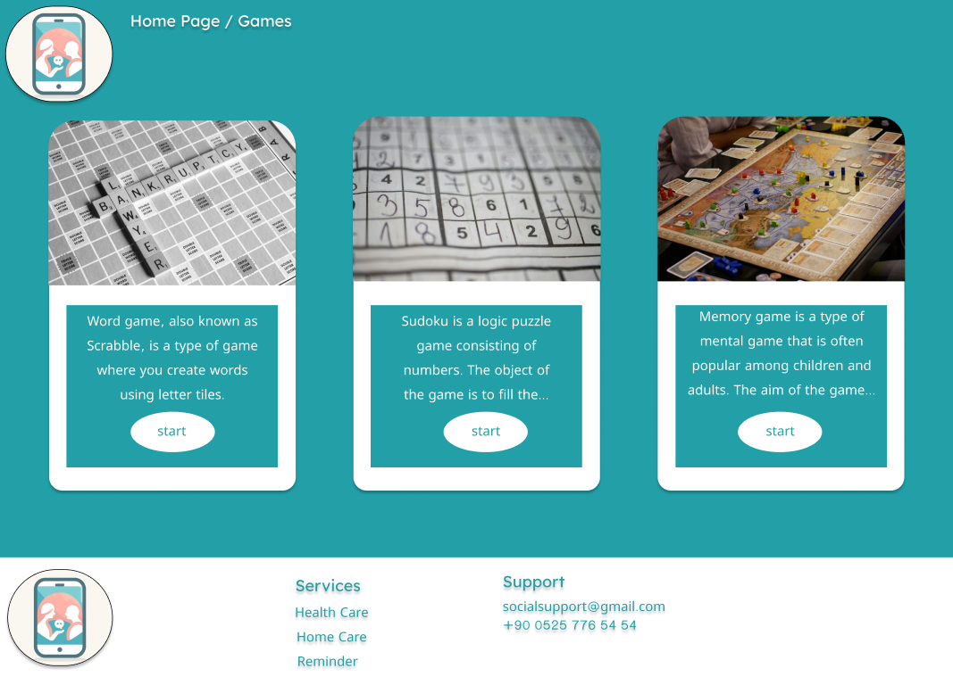

*Figure e. : Games*

**DOCTOR/NURSE**

Doctors and nurses working in one of the departments selected by the user can view the health profiles of users to make an accurate diagnosis for users and increase the benefits that the user will receive.

At the same time, doctors and nurses can add exercise and health advice, update existing information.

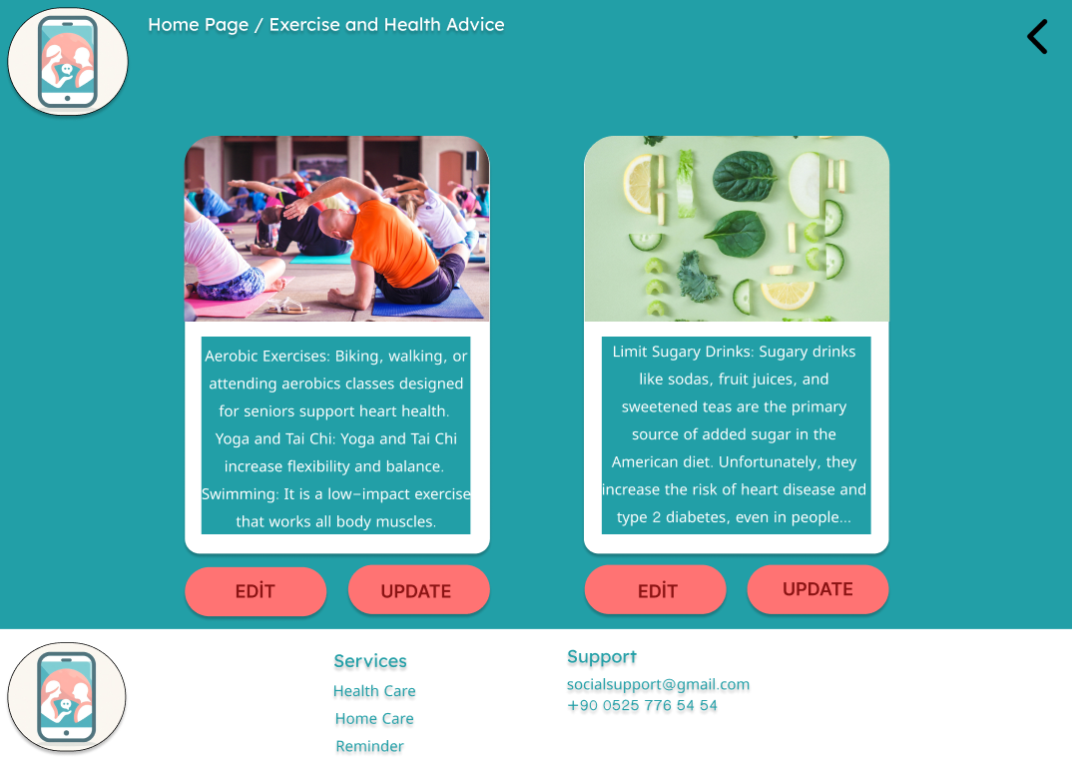

*Figure f. : Edit or update advices*

**ADMIN**

Admin can edit exercise and health recommendations, edit the chat room, and edit games. Admin gives the necessary permissions for doctors and nurses to add and update health and exercise recommendations.

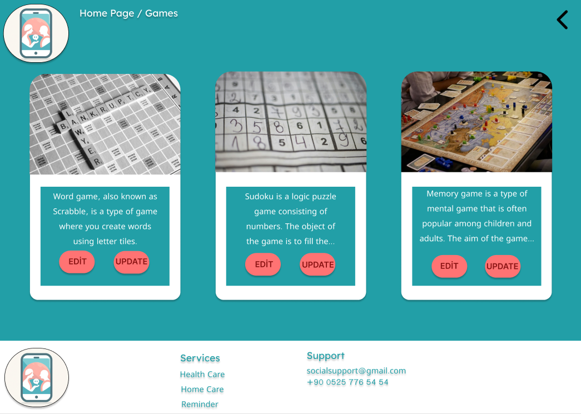

*Figure g. : Edit or update games*

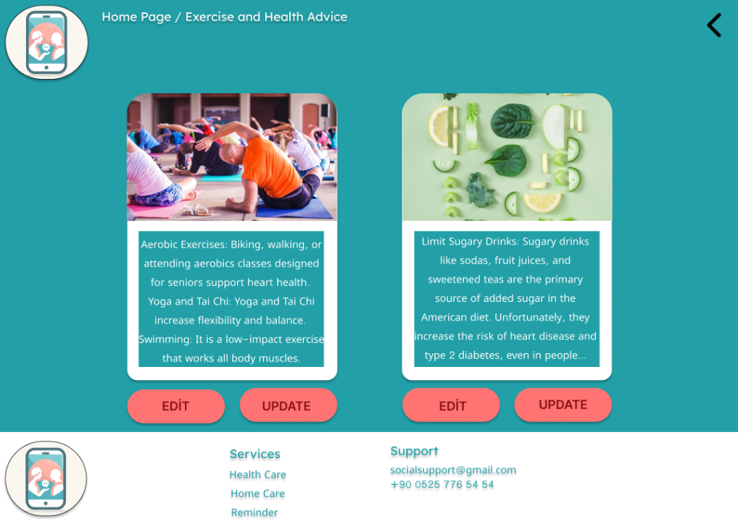

*Figure h. : Edit or update advices*

# 8. DISCUSSION

The projected solution of this project will have significant global, economic, environmental, and social changes, and seeks to dominate the issues of loneliness and social isolation of the old population. Through an electronic platform, which will be accessible for its use by the old population of Northern Cyprus, their quality of life will be increased, social interactions intensified, and total well-being promoted.

**Global Impact**

The platform can be a prototype for other regions facing similar problems with their aging population. Through the created links and providing a possibility for the elderly to communicate with others, it helped in fighting negative health outcomes of loneliness, which are depression, anxiety, and mental decline.

**Economic Impact**

The platform reduces health care expenditures in the process of reducing social isolation and improving mental health. Moreover, the fact that the platform will allow more independent living conditions for the elderly people and active involvement in a society will lead to a decrease in social service use and long-term care facilities.

**Environmental Impact**

The project promotes sustainability in the sense that less physical resources are required. The platform being digital will minimize use, as printed resources and those used in traveling, among others, are minimized. Again, the platform is intended to be run in an energy-saving manner hence reduces energy use.

**Social Impact**

The platform will increase social interactions among the elderly. The platform will also link between the elderly and other users with health experts, which ensured timely advice and support and hence better health outcomes. The chat room, the game, and the health advice are the integral elements of inclusion that promote social interaction, active life, and health.

**9. CONCLUSION**

This project is aimed at developing a digital platform that will be accessible and will help to respond to the increasing issue of loneliness and social isolation of the old population in Northern Cyprus. Generally, this platform will try to create a connected atmosphere in social life and hence improve the mental health and lifestyle of the users. This project has successfully achieved the following major landmarks: the development of an easy-to-use interface, creation of fundamental features like group chat rooms..

# 10. REFERENCES

* <https://www.figma.com/files/drafts?fuid=1364580255241135376>
* <https://www.drawio.com>
* <https://code.visualstudio.com>
* <https://maven.apache.org>
* <https://jdk.java.net/21/>
* <https://www.mysql.com>
* <https://spring.io/projects/spring-boot>
* <https://www.who.int>
* <https://www.pewresearch.org>
* <https://www.jmir.org>
* <https://www.cdc.gov>
* CDC's"Physical Activity for Older Adults" part.
* WHO's "Global Age-friendly Cities: A Guide" and "Integrated Care for Older People (ICOPE)" reports.

# 11. APPENDICES

**Java Code: AdminService.java**

@Service

public class AdminService {

@Autowired

private AdminRepository adminRepository;

public Admin createAdmin(Admin admin) {

return adminRepository.save(admin);

}

public Admin getAdminById(Long id) {

return adminRepository.findById(id)

.orElseThrow(() -> new ResourceNotFoundException("Admin not found for this id :: " + id));

}

public List<Admin> getAllAdmins() {

return adminRepository.findAll();

}

public void deleteAdmin(Long id)

Admin admin = getAdminById(id);

adminRepository.delete(admin);

}

}

**HTML Code: admin.html**

<!DOCTYPE html>

<html>

<head>

<title>Admin Panel</title>

<link rel="stylesheet" type="text/css" href="styles.css">

</head>

<body>

<h1>Admin Panel</h1>

<div>

<form id="createAdminForm">

<label for="adminName">Admin Name:</label>

<input type="text" id="adminName" name="adminName">

<button type="submit">Create Admin</button>

</form>

</div>

<div>

<h2>Admin List</h2>

<ul id="adminList">

<!-- Admin list shown here -->

</ul>

</div>

</body>

</html>

**Java Code: UserService.java**

@Service

public class UserService {

@Autowired

private UserRepository userRepository;

public User createUser(User user) {

return userRepository.save(user);

}

public User getUserById(Long id) {

return userRepository.findById(id)

.orElseThrow(() -> new UserNotFoundException("User not found for this id :: " + id));

}

public List<User> getAllUsers() {

return userRepository.findAll();

}

public void deleteUser(Long id) {

User user = getUserById(id);

userRepository.delete(user);

}

}

**HTML Code: index.html**

<!DOCTYPE html>

<html>

<head>

<title>Healthcare System</title>

<link rel="stylesheet" type="text/css" href="index.css">

</head>

<body>

<header>

<h1>Healthcare Management System</h1>

</header>

<main>

<section>

<h2>Welcome</h2>

<p>Please login or register to continue.</p>

</section>

<section>

<form id="loginForm">

<label for="username">Username:</label>

<input type="text" id="username" name="username">

<label for="password">Password:</label>

<input type="password" id="password" name="password">

<button type="submit">Login</button>

</form>

<form id="registerForm">

<label for="newUsername">New Username:</label>

<input type="text" id="newUsername" name="newUsername">

<label for="newPassword">New Password:</label>

<input type="password" id="newPassword" name="newPassword">

<button type="submit">Register</button>

</form>

</section>

</main>

</body>

</html>

**Java Code: DoctorService.java**

@Service

public class DoctorService {

@Autowired

private DoctorRepository doctorRepository;

public Doctor createDoctor(Doctor doctor) {

return doctorRepository.save(doctor);

}

public Doctor getDoctorById(Long id) {

return doctorRepository.findById(id)

.orElseThrow(() -> new ResourceNotFoundException("Doctor not found for this id :: " + id));

}

public List<Doctor> getAllDoctors() {

return doctorRepository.findAll();

}

public void deleteDoctor(Long id) {

Doctor doctor = getDoctorById(id);

doctorRepository.delete(doctor);

}

}

**HTML Code: doctor.html**

<!DOCTYPE html>

<html>

<head>

<title>Doctor Dashboard</title>

<link rel="stylesheet" type="text/css" href="styles.css">

</head>

<body>

<h1>Doctor Dashboard</h1>

<div>

<form id="createDoctorForm">

<label for="doctorName">Doctor Name:</label>

<input type="text" id="doctorName" name="doctorName">

<button type="submit">Create Doctor</button>

</form>

</div>

<div>

<h2>Doctor List</h2>

<ul id="doctorList">

<!—Doctor list shown here -->

</ul>

</div>

</body>

</html>